**Demonstrate how environments are used in Postman**

Step-1:

First open postman

Step-2:

Then I click on “+” sign to create a collection

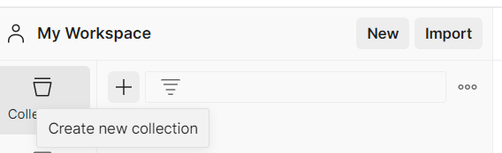

Step-3:

Then I click on Blank Collection

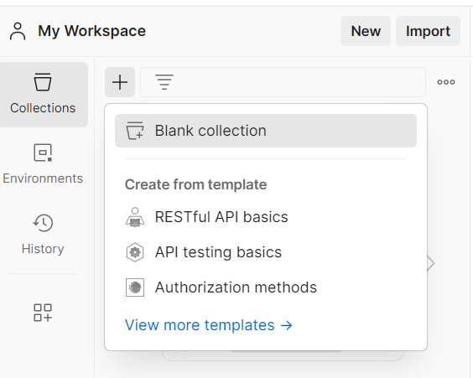

Step-4:

Then I click on 3 dot then select Add request

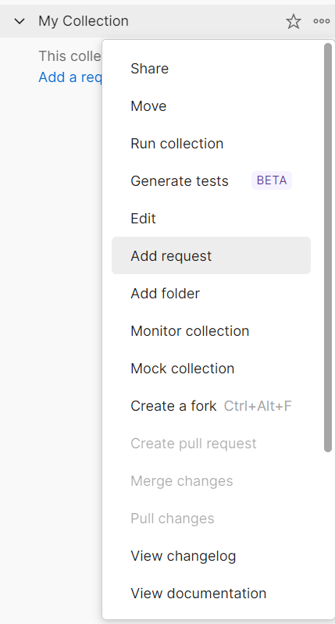

Step-5:

Then I rename it and enter request url

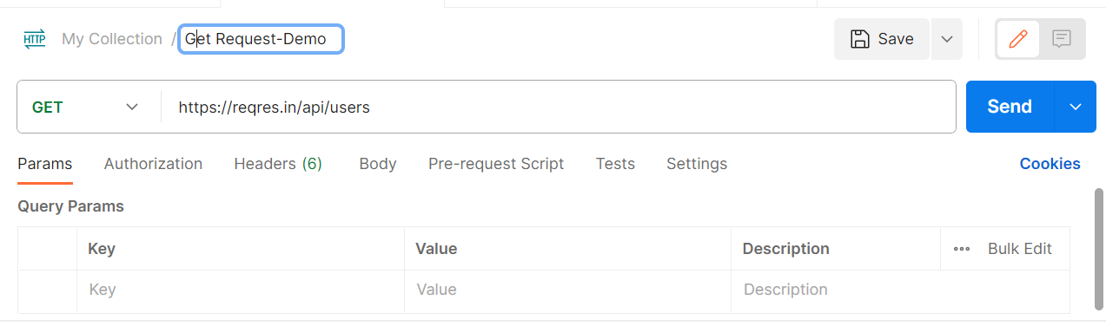

Step-6:

Then click on environment and then click on “+” sign to create environment variable

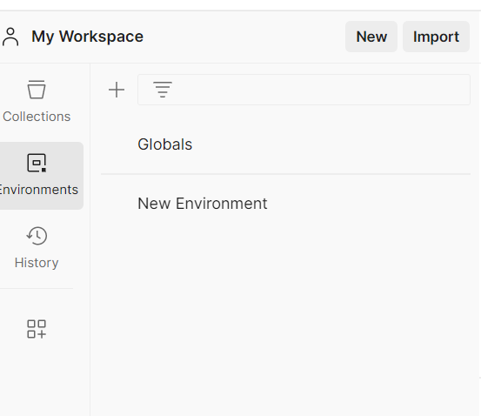

Step-7:

Then I create a variable and save it

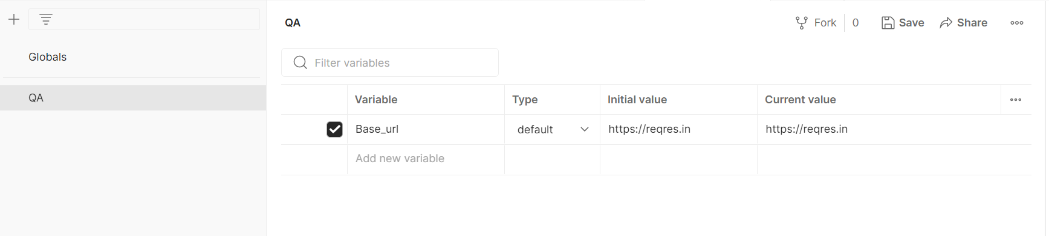

Step-8: Then I select my QA environment

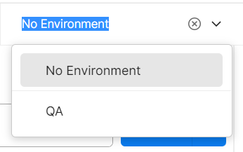

Step-9:

Then I select my variable in url and click on send



